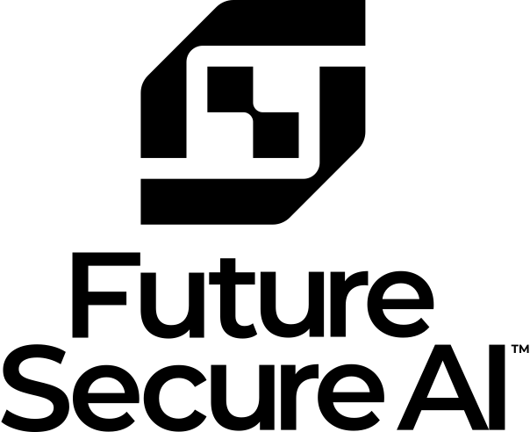
Future secure Ai
CEOs Learning about AI with Personal AI Tutors
Updated – June 18, 2025

Introduction: A Transformative Opportunity for Healthcare Leaders
Future Secure AI (FSAI) is thrilled at the opportunity to partner with the Ontario Hospital Association (OHA) in delivering an innovative, comprehensive program for AI training tailored to Ontario hospital executives. As the healthcare industry navigates increasing demands for efficiency, innovation, and data-driven solutions, we believe this offering represents a pivotal step toward empowering leaders to confidently adopt AI strategies that address their unique organizational needs.
Our solution is built on two distinct, yet synergistic, strengths: FSAI’s unparalleled expertise in enterprise AI deployment and ULTIMO’s leadership in learning science and educational technology. FSAI acquired ULTIMO and we now operate as a single company. These capabilities allow us to deliver a hyper-personalized, self-guided program that balances foundational AI knowledge with healthcare-specific applications. From rural hospitals to urban networks, this approach ensures accessibility for a diverse range of participants, equipping them to develop actionable AI adoption strategies tailored to their operational realities.
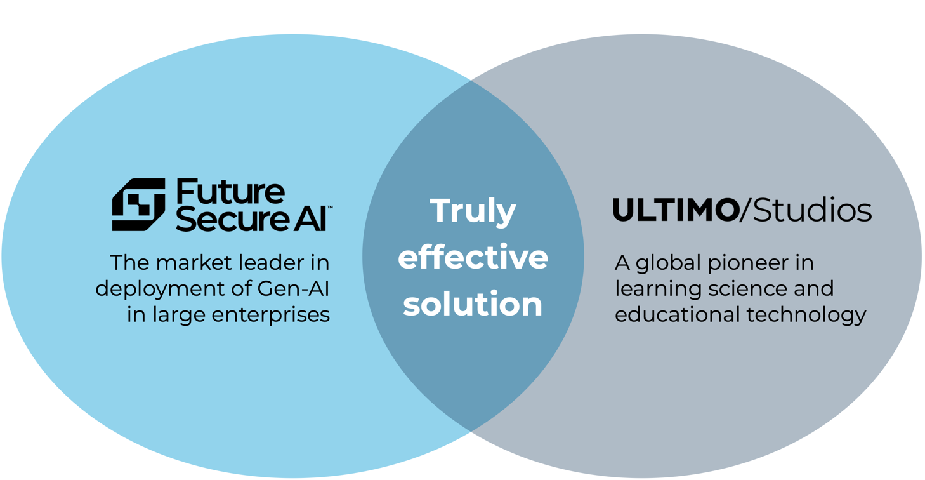

By combining enterprise-grade privacy, cyber and data security, open-ecosystem flexibility, and a phased, scalable rollout, FSAI’s offering directly aligns with OHA’s vision for leadership education. We are excited to help Ontario hospital executives to not only explore the potential of AI but also take the essential steps toward integrating these transformative technologies into their organizational strategies. Together, we can set a new standard for knowledge transfer and leadership development in the healthcare sector.

SECTION
01
Corporate Overview
History and Distinctiveness
of Future Secure AI

- Future Secure AI (FSAI) - Company Overview
  - Mission and Vision
- FSAI is the leader in the fast-growing market for enterprise transformation through the design and deployment of digital AI workers at an industrial scale.
- A joint venture with the Macquarie Group (ASX:MQG), a global investment bank, FSAI has multiple partnerships with leading companies in numerous industry verticals (including healthcare) and geographic regions.
- As the number of digital AI workers in an organization increases to an industrial scale (i.e., hundreds or thousands), a full Operating System will be required to manage that AI workforce. The FSAI Operating System has been designed to include the feature-functionality critical for a large enterprise to manage its AI workforce.

  - Basic Details
- Legal Name of the Company: Future Secure AI Pty Ltd
- Year Established: Incorporated in September 2023
- Headquarters Address: Level 3, 44 Martin Place, Sydney, 2000, NSW, Australia

  - Business Structure
- Type of Business Entity: Corporation, Australian Proprietary Limited Company (Australian Business Number: 86 670 932 073)
- Parent Company (if applicable): 40% owned by Macquarie Group Limited (ASX:MQG), an AUD$90 billion market cap global investment firm. Future Secure AI Pty Ltd operates as a Joint Venture with Macquarie Group.
- Subsidiaries or Affiliates: FSAI owns 80% of Future Secure AI Middle East Limited, a Middle East subsidiary incorporated in the Abu Dhabi Global Market (ADGM).

  - Healthcare Experience
- FSAI’s core strengths are in functional expertise rather than being confined to specific industries. The sweet spot is business processes with high levels of administrative steps and systems. This is of course very applicable to the healthcare industry.
- We are actively engaged with a large private hospital network (480 facilities in 8 countries) as well as with one of the largest health insurance companies in Australia.
- We are in conversations with the largest Catholic hospital network in Australia as well as one of the leading hospitals in the United States.
- FSAI is in discussions with Ontario hospitals regarding deployment of digital AI workers capable of handling essential (yet often repetitive and time-consuming) administrative work. This would free up human workers or their associated budgets to spend their time on more critical and meaningful work, like patient care.
- Almost all hospital back-office operations would benefit from FSAI’s AI workers. We have direct experience delivering cost savings, time compression, and quality improvement in Finance, Treasury, Tax, HR, Customer Service, Operations, Supply Chain, Information Management, and other functional areas.
  - Key FSAI Executives
Name | Biography
Mehrdad Baghai  Co-founder and Co-CEO | Mehrdad is a highly experienced entrepreneur having built a number of companies over the last three decades. He has been a globally recognized strategist and advised CEOs and Boards of large companies around the world including the Macquarie Group. He is a former partner at McKinsey & Company where he led the Firm’s global growth practice in the 1990s.
Michael Hunter  Co-founder and Co-CEO | Highly experienced entrepreneur and senior executive, building a number of technology companies including in AI, EdTech and semiconductors. Prior to co-founding FSAI, Michael was an investment banker at Macquarie Capital and an adviser at L.E.K. Consulting, including advising Australia’s largest health advice service (government entity).
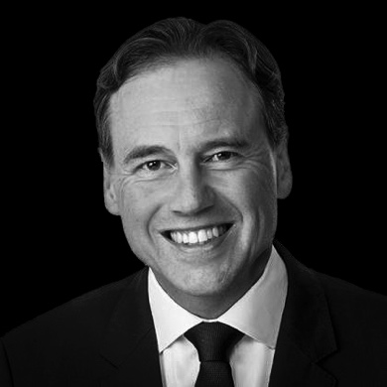The Honourable Greg Hunt  Senior Advisor, Healthcare | Greg is a former Cabinet Minister in the Australian Government, including serving as the Australian Health Minister from 2017 to 2022 during the COVID-19 pandemic. He oversaw an annual budget of AUD$132 billion, 17 portfolio agencies and 7,000 staff. Prior to his political career, Greg was at McKinsey & Company and also served as a lawyer and Associate to the Chief Justice of the Australian Federal Court.
Sarah Ryerson  Executive Director, Canada Healthcare | Sarah is an experienced business builder and executive for technology companies. Sarah led Business Operations at Cohere, an LLM-builder, in 2021 and 2022. Prior to Cohere, Sarah worked in capital markets as the President of Datalinx (the information services arm of TMX - Canada’s largest exchange). Earlier in her career, Sarah spent 5 years at Google in Strategy & Operations roles, first in Canada and then globally. Sarah started her career at McKinsey & Company where she worked across industries including healthcare, mining, retail and financial services.
Ricardo Lamas  Chief Technology Officer, Director | Ricardo is a highly experienced technologist with over 20 years of expertise. Prior to FSAI, he founded an AI company, served as Head of Engineering in a large Australian FinTech and consulted to multiple enterprise customers. Ricardo has deep expertise in AI and web3.0 applications and is fluent in English and Portuguese.
  Cody Collins  Tech Lead, US & Canada | Cody Collins is a technical leader with strong experience in delivering AI solutions. Prior to joining FSAI, he worked with startups at Amazon Web Services as an AI & ML Specialist building agentic workflows, training and tuning models, and deploying MLOps pipelines. Cody has an extensive background working with customers across industries including healthcare, professional services, and non-profits building complex technical solutions.
  Alexandrea Logan  Engagement Lead | Alex (Alexandrea) Logan commenced her career as a high school teacher and has spent the last 10 years in operations, program management and managing strategic projects.  Alex holds Masters in both Public Administration and Social Work from Columbia University.

  - Company Future: Projected Growth and Key Milestones
- FSAI is experiencing rapid growth, driven by strong enterprise demand and support from Macquarie Group. Our focus over the next few years includes scaling operations, expanding our team, and strengthening our global presence with high-level targets as follows:
- Next 6 Months: Grow from 80 to 150 FTEs, expand into Canada and the U.S., and scale our Healthcare and Resources Business Units globally.
- Next 24 Months: Increase to 400-500 FTEs, achieve AUD $150M in annual recurring revenue through use case expansion and proof-of-concept conversions, and deepen our presence in key industry clusters.
- We are well-positioned to meet evolving enterprise needs while achieving substantial milestones globally.

SECTION
02
Solution Overview
Future Secure AI’s
Key Value Offering

- Three Key Advantages: A Transformative Approach to AI Education
Future Secure AI (FSAI) provides a cutting-edge solution tailored to Ontario hospital executives, enabling them to develop a deep understanding of AI and adopt it strategically. Our offering is built on three core strengths:
- Deep Understanding of AI especially within the Healthcare Context: FSAI has unmatched expertise in the deployment of AI into large enterprises. We provide hospital executives with content that combines foundational AI knowledge and healthcare-specific applications, equipping them to create actionable AI adoption strategies.
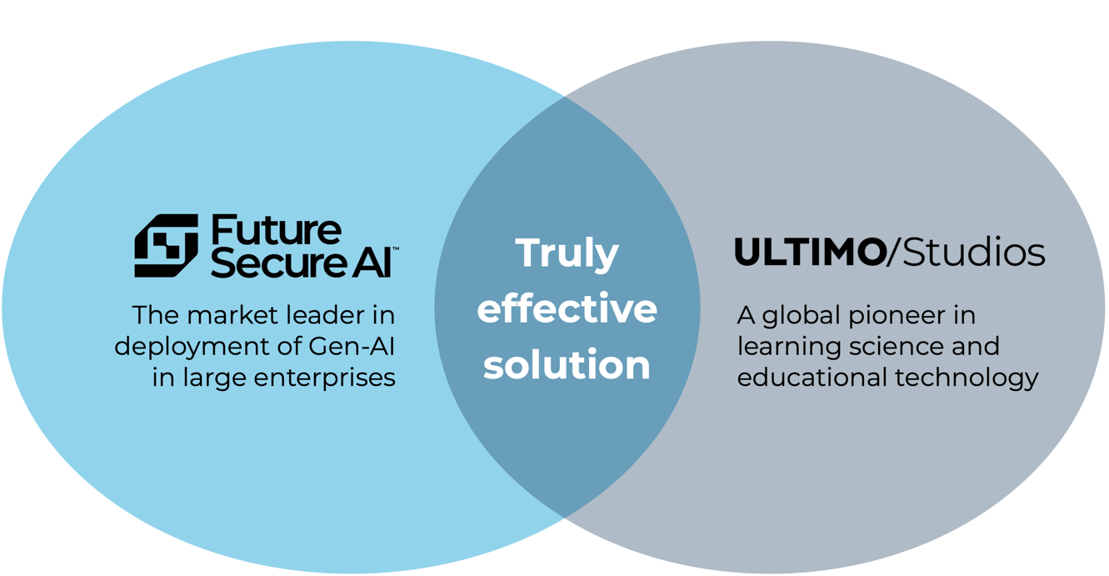
- Proven Expertise in Learning Science: Together with ULTIMO/Studios (which has been fully acquired by FSAI), we deliver a program designed for maximum engagement and knowledge retention. Our solution specializes in hyper-personalized learning solutions, knowledge transfer, and advanced training methodologies. Our previous experience ensures the program meets diverse learning needs, given their experience base ranges from executive training to university courses and even youth in Indigenous communities.

- Learning Through AI, Powered by AI Tutors: Our approach embodies the principle that "the medium is the message." Executives don’t just learn about AI—they experience its transformative potential firsthand through hyper-personalized AI tutors. Traditional learning methods cannot achieve this dynamic, immersive experience. It’s the difference between merely reading about a safari and actually embarking on one.
The overlap of these three strengths forms a unique value proposition: CEOs Learning about AI with Personal AI Tutors. Our solution goes beyond traditional approaches by combining AI-powered personalization with a strong pedagogical foundation, creating an impactful learning experience that equips leaders to adopt AI strategically.
To give a sense of what an interaction between a hospital CEO (Jane on the right) and a personal AI tutor (Pierre on the left) feels like, here is a short snippet of a conversation. Remember this can happen on a chat device or over voice like a phone call while driving home:
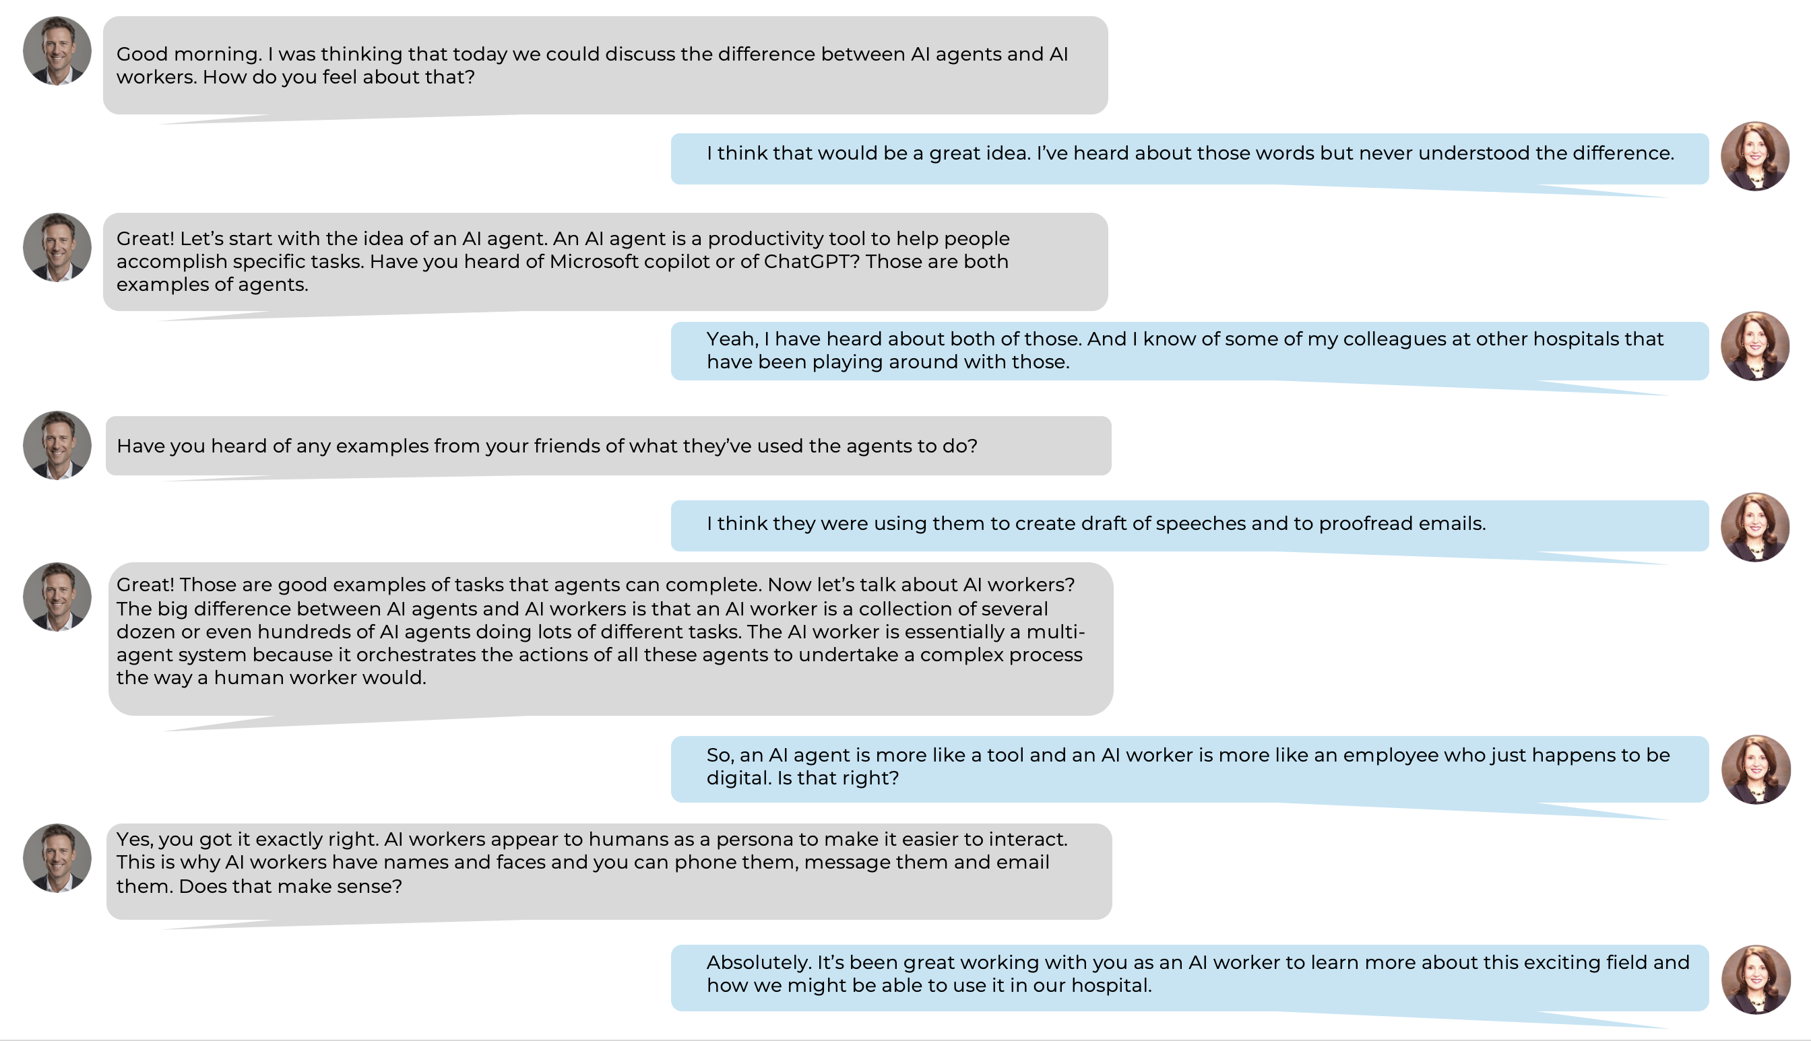

Importantly, the interaction does not need to follow a deterministic, pre-determined pathway or course design. The conversation could just as easily have started with the CEO asking a question, “Today, I heard something about RAGs but have idea what they are. Can you please explain that to me Pierre?”
This personalized approach ensures that Ontario hospital executives receive a program that not only facilitates knowledge transfer related to AI topics, but one that also empowers them to make informed decisions about AI adoption, aligning directly with the OHA’s goals for this RFQ.
- A Self-Guided, Asynchronous Program for Executives
The FSAI solution directly aligns with the OHA’s vision of a phased, self-guided knowledge transfer program. Executives will progress through multiple virtual modules, covering:
- Foundational AI Knowledge: Participants will begin with an overview of AI concepts and applications relevant to hospitals. Modules will address the individual level (e.g., patient or clinician), the organizational level (e.g., administrative, back-office), and the health system level (e.g., community partnerships, patient flow).
- Developing AI Strategies: The program supports executives in creating implementation strategies, organizational policies, and evaluation frameworks necessary for hospital-wide AI adoption. Topics will include privacy, cybersecurity, ethics, and safety. Some of these themes are further detailed in the sections below.
- Capstone Project Approach: Each participant will apply the knowledge and skills gained by developing an AI Worker Use Case specific to their organization. This real-world application ensures practical outcomes and alignment with the OHA’s goals.
Our hyper-personalized AI tutors will guide participants through the content, while "orthodox" components will provide foundational learning for those newer to AI concepts. This ensures accessibility for a range of AI literacy levels, including rural and urban leaders.
- AI Educational Content: Partial List of Themes
The following topics and themes form a critical part of the AI knowledge transfer program, equipping hospital executives with the tools and insights needed to adopt AI responsibly and strategically in their organizations:

  - Understanding AI Capabilities and Limitations
- Explore foundational concepts such as machine learning, natural language processing, and generative AI.
- Understand the difference between single-agent AI tools (e.g., GPT models) and more complex multi-agent systems (MAS), including their potential in orchestrating intricate tasks and delivering significant efficiencies through fully operational AI workers.
- Recognize how AI applications can vary in scope and complexity, addressing needs at the patient, organizational, and system-wide levels.

  - Privacy, Cybersecurity, and Ethical Considerations
- Develop a deep understanding of privacy, cybersecurity, and ethical issues unique to AI adoption in hospitals, ensuring alignment with Ontario’s stringent data protection and regulatory requirements.
- Learn to evaluate the suitability of cloud-based and on-premises AI platforms, considering data security risks and internal controls (e.g., row-level data access restrictions).
- Examine frameworks for mitigating risks associated with bias, AI “hallucinations,” and unintended consequences in decision-making.

  - Leveraging Advanced AI Architectures
- Discover the advantages of multi-LLM (Large Language Model) architectures, including how multiple models can work in parallel to improve accuracy, reduce hallucination risks, and optimize costs.
- Understand the balance between deterministic workflows (e.g., traditional robotic process automation) and the creative potential of generative AI, and how combining these approaches can address real-world hospital challenges.
- Learn practical strategies for deploying AI solutions tailored to hospital-specific use cases.
  - Developing AI Adoption Strategies
- Gain the skills to create organizational policies and readiness frameworks for AI adoption, including tools for assessing AI maturity and identifying actionable opportunities.
- Explore successful case studies and frameworks from the healthcare sector and beyond, highlighting implementation strategies that balance innovation with practicality.
- Develop evaluation methodologies for measuring the success of AI initiatives in terms of impact, efficiency, and compliance.
  - Compliance and Regulation in Healthcare AI
- Address the unique regulatory landscape of healthcare AI in Ontario, including adherence to the Personal Health Information Protection Act (PHIPA) and Quality of Care Information Protection Act (QCIPA).
- Learn best practices for ensuring compliance when deploying AI solutions, including penetration testing, internal data governance, and maintaining operational integrity.
- Learn how to manage a hybrid workforce comprising both human and digital AI workers in collaboration.
  - Capstone Project Preparation: Practical Application
- Prepare for the capstone project by learning how to assess your organization’s AI readiness, prioritize potential AI use cases, and align strategies with institutional goals.
- Explore tools for designing AI adoption roadmaps and setting measurable goals to evaluate success post-implementation.
By integrating these themes, the program ensures a comprehensive, executive-level education on AI that addresses both the strategic and operational challenges facing Ontario hospital leaders.
- Special Learning Events and Peak Experiences
In addition to the learning approaches outlined above, we would also include some headline events to inspire action and learn about the forefront of what is happening in AI globally. Mehrdad Baghai, the Co-Founder and Co-CEO is well known to all Ontario hospital CEOs through his presentation at the OHA Summit, as well as the faculty role with the Proximity Institute’s leadership retreats. Included in this proposal are two events featuring Mehrdad and his perspectives as the leader of a world-leading AI company as well as other FSAI global leaders. Given Mehrdad’s normal speaking fees, these bundled events would represent a stand-alone value of around $100,000.

  - Introduction to AI virtual webinar
- Mehrad and other members of the FSAI team will lead a 1-hour virtual workshop for hospital leaders in advance of the launch of the executive learning modules in the summer or fall of 2025.
- The event will serve as a foundational learning opportunity for CEOs to understand the core concepts of AI.
- The event can be webcast live as well as recorded for those not able to attend the original webinar.

  - Advanced Workshop in Toronto
- Mehrdad can also lead an advanced 4-hour workshop for hospital leaders in a Toronto venue October 9th (in the afternoon) or October 10^{th,} 2025.
- The event will serve as an ability to deep dive into use case ideation and the alternative strategies for large enterprise environments like hospitals.
- The event cannot be webcast or recorded given it’s a hands-on session.

  - Special Virtual Event for Northern Communities
- We understand the 50+ hospitals in the northern regions of Ontario have a very different context and capability set to GTA hospitals.
- This special 2-hour workshop would focus on how major foundations have funded AI work in remote setting with mainly indigenous populations in other parts of the world.
- The event would be webcast and could be recorded for those not able to attend in person.
- We would engage other FSAI healthcare leaders who have managed remote communities in Australia.

SECTION
03
Statement of Work
Assumptions and Estimate of Cost for Services

- Scope of Work
  - High Level Scope Summary
The major deliverables to be provided for this project are as follows:
- Project Plan: detailed end-to-end project plan covering project kickoff through to final benefit realization.
- Stakeholder Assessment: to articulate the current spectrum of existing knowledge and learning needs across the target stakeholder group.
- Business Requirements: detailed requirements covering the curriculum content and delivery needs for the target stakeholder group.
- Communication and Engagement Plan: to provide clarity of timing and scope of planned communications and engagement activities throughout the life of the project.
- Curriculum: curriculum content and AI delivery channel to achieve target learning outcomes.
- User Onboarding Process: clear process for onboarding the CEOs.
- User Support Framework: clear support channels for access by CEOs to remove any barriers to adoption.
- Program Evaluation Framework: framework for ensuring any key learnings are captured throughout the project and that there is a clear assessment of the effectiveness of the project upon completion.
  - Budget Breakdown
The budget breakdown for the program rollout to the initial target group of CEOs is displayed in the table below. The main factors that could impact the budget are the final decision on how much curriculum to include and whether the curriculum continues to be updated beyond the original period of programming, the addition of new channels (such as voice), and whether the audience will be expanded beyond just the CEOs.

DETAILED ITEMS | ASSUMPTIONS | UNITS | UNIT RATE $CAD | UPFRONT $CAD | ANNUAL $CAD
Setup Cost Items
Project Management | 10 days effort | 10.0 | $900 | $9,000
Implementation Support | 15 days effort | 15.0 | $600 | $9,000
Sub Total |  |  |  | $18,000 | $ -
Knowledge and AI Training
Consultancy - Initial Detailed Scoping | 10 days effort | 10.0 | $900 | $9,000
Content Curation | 20 days effort for hospital specific content | 10.0 | $600 | $6,000
Content Curation | 10 days effort to modify existing content | 10.0 | $600 | $6,000
Content Ingestion and Testing | 10 days effort | 10.0 | $600 | $6,000
Sub Total |  |  |  | $27,000 | $ -
IT Infrastructure Setup
FSAI container on OHA network |  | 30 | $600 | $18,000
Interface with LLMs |  |  |  | $6,000
Access/Security Management |  |  |  | $8,000
Sub Total |  |  |  | $32,000 | $ -
Recurring Cost Items
Hyper Personalised Individual Tutors | Assumes 150 users ($4k/mo) | 12.0 | $4,000 |  | $48,000
Activity Tracking and Performance |  |  |  |  | $9,000
IT Solution Support | FTE = 0.05 @ $150K p.a. | 0.05 | $150,000 |  | $7,500
Customer Support | FTE = 0.1 @ $80k p.a. | 0.10 | $80,000 |  | $8,000
Sub Total |  |  |  | $ - | $72,500
Total |  |  |  | $77,000 | $72,500
 |  |  |  |  | $149,500
*Additional Incremental Users can be added for $30 per user per month or $360 p/a

  - Project Management Approach
Successful project management hinges on treating this as a Change Management challenge, not just a Technology Implementation, with effective communication and engagement being key to success.
Targeting CEOs is challenging due to their diverse AI perspectives, varying learning preferences, and limited time. Our project approach addresses this by offering tailored engagement strategies, providing distinct advantages over traditional methods.
The core phases for this project will involve:
- Stakeholder analysis
- User interviews (sample of CEOs)
- Detailed scope and requirements clarification
- Curriculum development, testing and refinement
- Communications and engagement
- Program rollout and onboarding
- Program support
- Program evaluation and refinement

SECTION
04
Conflicts Register

Future Secure AI confirms that we have no conflicts that would apply or be relevant to this OHA RFQ.
As a matter of company policy, we do not engage with organizations in certain industries, including gambling, military defence, or other sectors that may be inconsistent with our core values.
Additionally, we do not operate in or engage with entities in countries subject to significant international sanctions.
We are committed to aligning with OHA’s values and objectives in this initiative.

SECTION
05
Evidence of Impact
Feedback and Ratings by
Past Participants

At Future Secure AI, participant satisfaction and tangible impact are at the core of every initiative we undertake. Our past projects demonstrate not only high levels of participant engagement and satisfaction but also meaningful outcomes in diverse educational and organizational contexts. Below, we provide details from five representative projects (including the use of hyper-personalized AI tutors) that highlight our track record in delivering virtual learning experiences, innovative educational methodologies, and robust implementation strategies.
- Past Projects: Representative Examples
We have extensive experience designing AI tutors and creating virtual learning experiences for young learners, educators, industry professionals, university students, and advanced high school learners. Each of these courses was designed to meet the specific needs and professional expertise of our partners.
  - University of Tasmania – Educating Industry Professionals about AI
- In partnership with the University of Tasmania (UTas), we designed and developed an interactive course for adult professionals that introduces AI (including the history of AI and different AI models) and covers topics including Generative AI and Generative AI tools; Digital Workers; and the onboarding of Digital Workers.
- The course is shaped by the expert insights of Future Secure AI’s co-founders and is based on learning science and human-centered design. The course is also informed by the unique needs of UTas’s professional learning community, ensuring that their learning about generative AI is relevant to their professional contexts.
- The course has just launched and UTas has already expressed interest in additional modules.
  - XPRIZE Foundation
- The XPRIZE Foundation is a global non-profit organization that designs and hosts public competitions intended to encourage technological development to provide solutions for the world’s most urgent challenges. With XPRIZE, we designed and developed XPRIZE Connect which included nineteen interactive learning experiences for advanced high school and university students.

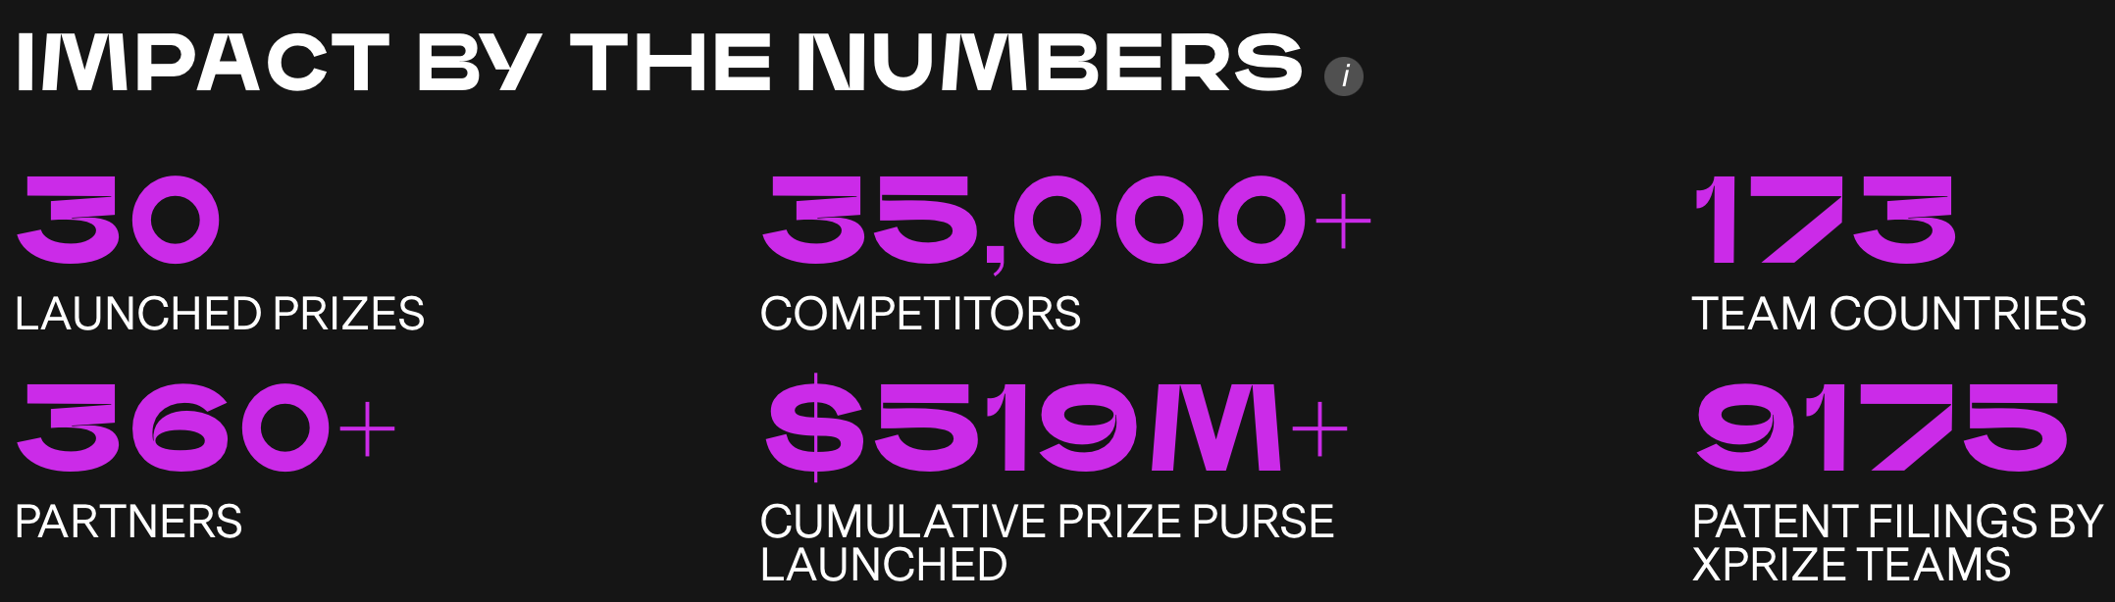

- This transformative learning experience operates as a self-paced modularized course, offering an immersive learning experience to promote students’ deep understanding of complex issues and teach them techniques to solve them. Learners in the US, Australia, Italy, and Japan, among other countries, are participating in XPRIZE Connect, and the University of New South Wales has developed a national program for the course.



- UNSW Deputy Vice-Chancellor, Education and Student Experience, Professor Sarah Maddison, said a large part of XPRIZE Connect’s appeal lay in its ability to empower young people to address major problems and connect to a global community of young people seeking to make a difference: “XPRIZE Connect is unique in providing scaffolded learning that is both engaging and inspiring, and focusing on students’ agency to tackle issues that matter most to them and their future. It equips students with the confidence, skills and mindset to become changemakers.”
  - University of Technology, Sydney
- In partnership with the University of Technology Sydney (UTS), we designed and developed “EmpowerED Leadership Lab,” a multi-module interdepartmental course.
- EmpowerED is an on-demand, online, holistic learning experience that builds a foundation for leadership grounded in principles of equity, social justice, global citizenry, and community change.
- Both UTS students and staff participated in the launch of EmpowerED in 2023 with a participant reflecting that, “My worldview has drastically changed after going through this course, as a lot of questions have been asked of myself through the journey of going through all the modules.”
- Past Projects: Examples of Hyper-Personalized AI Tutors
  - Project Airport (Australia)
- Project Description: “Project Airport” a collaboration between ULTIMO’s parent company (the High Resolves Group) and the Paul Ramsay Foundation, explores the transformative potential of AI in education to enhance outcomes for disadvantaged young Australians. Focus areas include AI tutoring, dynamic formative assessments, and the integration of AI digital workers.
- Key Learnings
- Students: AI tools like ULTIMO/Ai increased student motivation and engagement, particularly in English, Science, and Maths. Challenges included device limitations and varying digital literacy levels.
- Teachers: Teachers appreciated AI's ability to personalise learning and reduce administrative workloads but highlighted the need for extensive training and support.
- AI Digital Workers: Case studies showed significant productivity gains. For example, tasks previously requiring weeks were reduced to minutes. Effective deployment necessitates thoughtful change management.

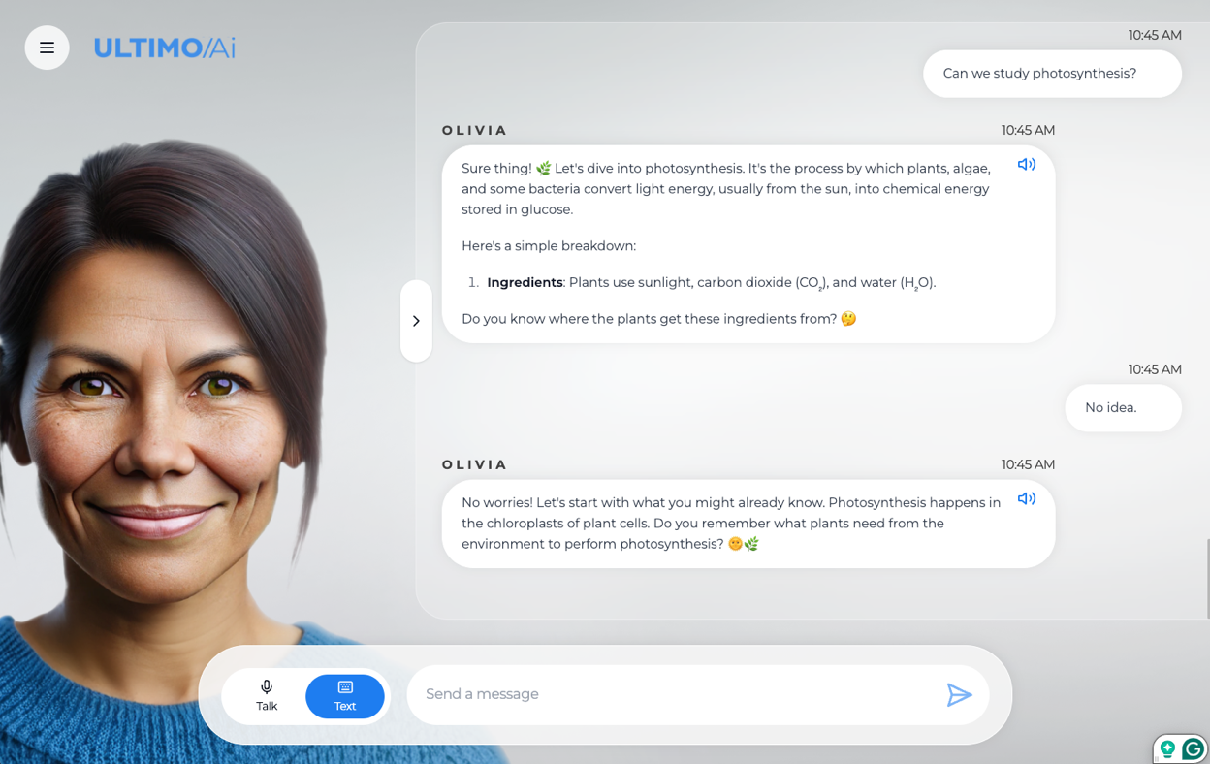
- Testimonials
- “The AI tutor helped me stay on track and made studying easier,” - student participant
- “It’s like having a colleague that’s always available,” - teacher participant
- Summary
- Project Airport’s innovative application of AI tools demonstrated potential in addressing educational inequality and increasing productivity. Insights gained will shape future efforts, particularly the Bayesian Adaptive Trial planned in 2025, to refine AI integration in both classroom and organizational settings.
  - Project Camino (Mexico)
- Project Description: “Project Camino” aimed to equip vulnerable youth (ages 13–18) in Mexico with social, emotional, and future-ready skills, fostering independence and inclusivity. Over 400 young participants engaged with “Carla,” an AI tutor accessible via WhatsApp, in three levels of educator intervention: no, low, or high.

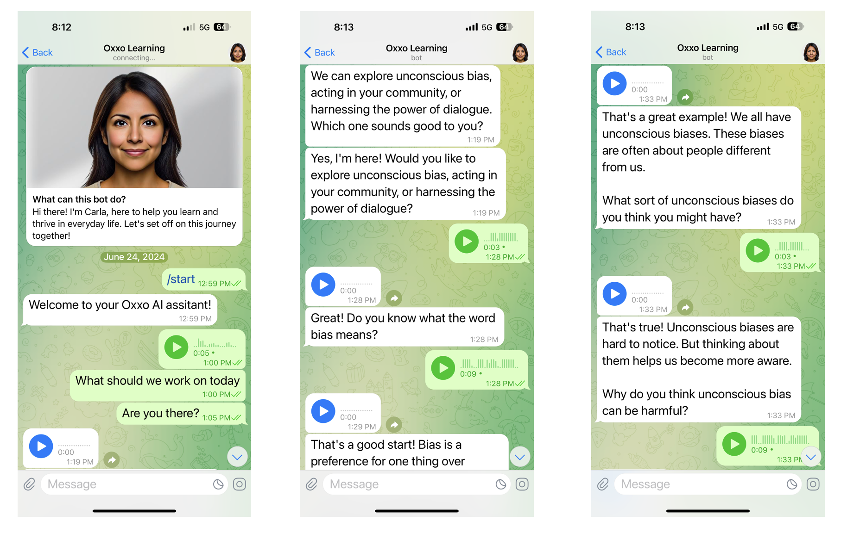
- Key Learnings
- The no intervention model had the highest levels of engagement and usage providing strong evidence for the power of hyper-personalized learning.
- Trust and Engagement: Carla provided a trusted, safe space for students, particularly in vulnerable settings, encouraging open communication and emotional support.
- Educational Impact: Carla proved versatile, boosting creativity, motivation, and learning outcomes. Content was well-received, with a high satisfaction rate (average 84%).
- Scalability: Carla was recognised for her adaptability, accessibility, and personalized approach, making “her” a valuable tool in diverse educational contexts.
- Quotes/Testimonials
- “Carla became a trusted companion, offering a non-judgmental space to discuss sensitive topics.”
- “Learners viewed Carla as both a mentor and a learning ally, enhancing their engagement and creativity.”
- 94% of students recommend Carla to their peers, citing her reliability and tailored learning experience.
- Summary:
- Carla demonstrated immense potential to transform education in challenging contexts by addressing gaps in engagement and accessibility. She fostered independent learning, enhanced life skills, and supported marginalized students in achieving academic credentials.

SECTION
06
Background Information
Additional Documents and Examples of Previous Work

At Future Secure AI (FSAI), our organizational values drive everything we do, shaping our approach to innovation, collaboration, and impact. These values are encapsulated in the acronym BRAVER, which reflects the principles that guide our work and our commitment to excellence.
The BRAVER framework—Bold, Rigorous, Adaptable, Valued, Earnest, and Relentless—ensures we remain forward-thinking, maintain the highest standards, and consistently deliver meaningful solutions to our partners and clients. These values resonate deeply with the mission of empowering Ontario hospitals with the knowledge and tools to adopt AI effectively.

